Dpudatatransfer.c

(started at 4:45) script stopped at 4:51(so almost 7 minutes where as in local it takes around 10 minutes):

For parameter

#define N_POINTS 10000 *// Number of points*

#define DIMENSIONS 2

#define K 6 *// Number of clusters*

#define MAX_ITERATIONS 15

#define TRANSFER_SIZE 256

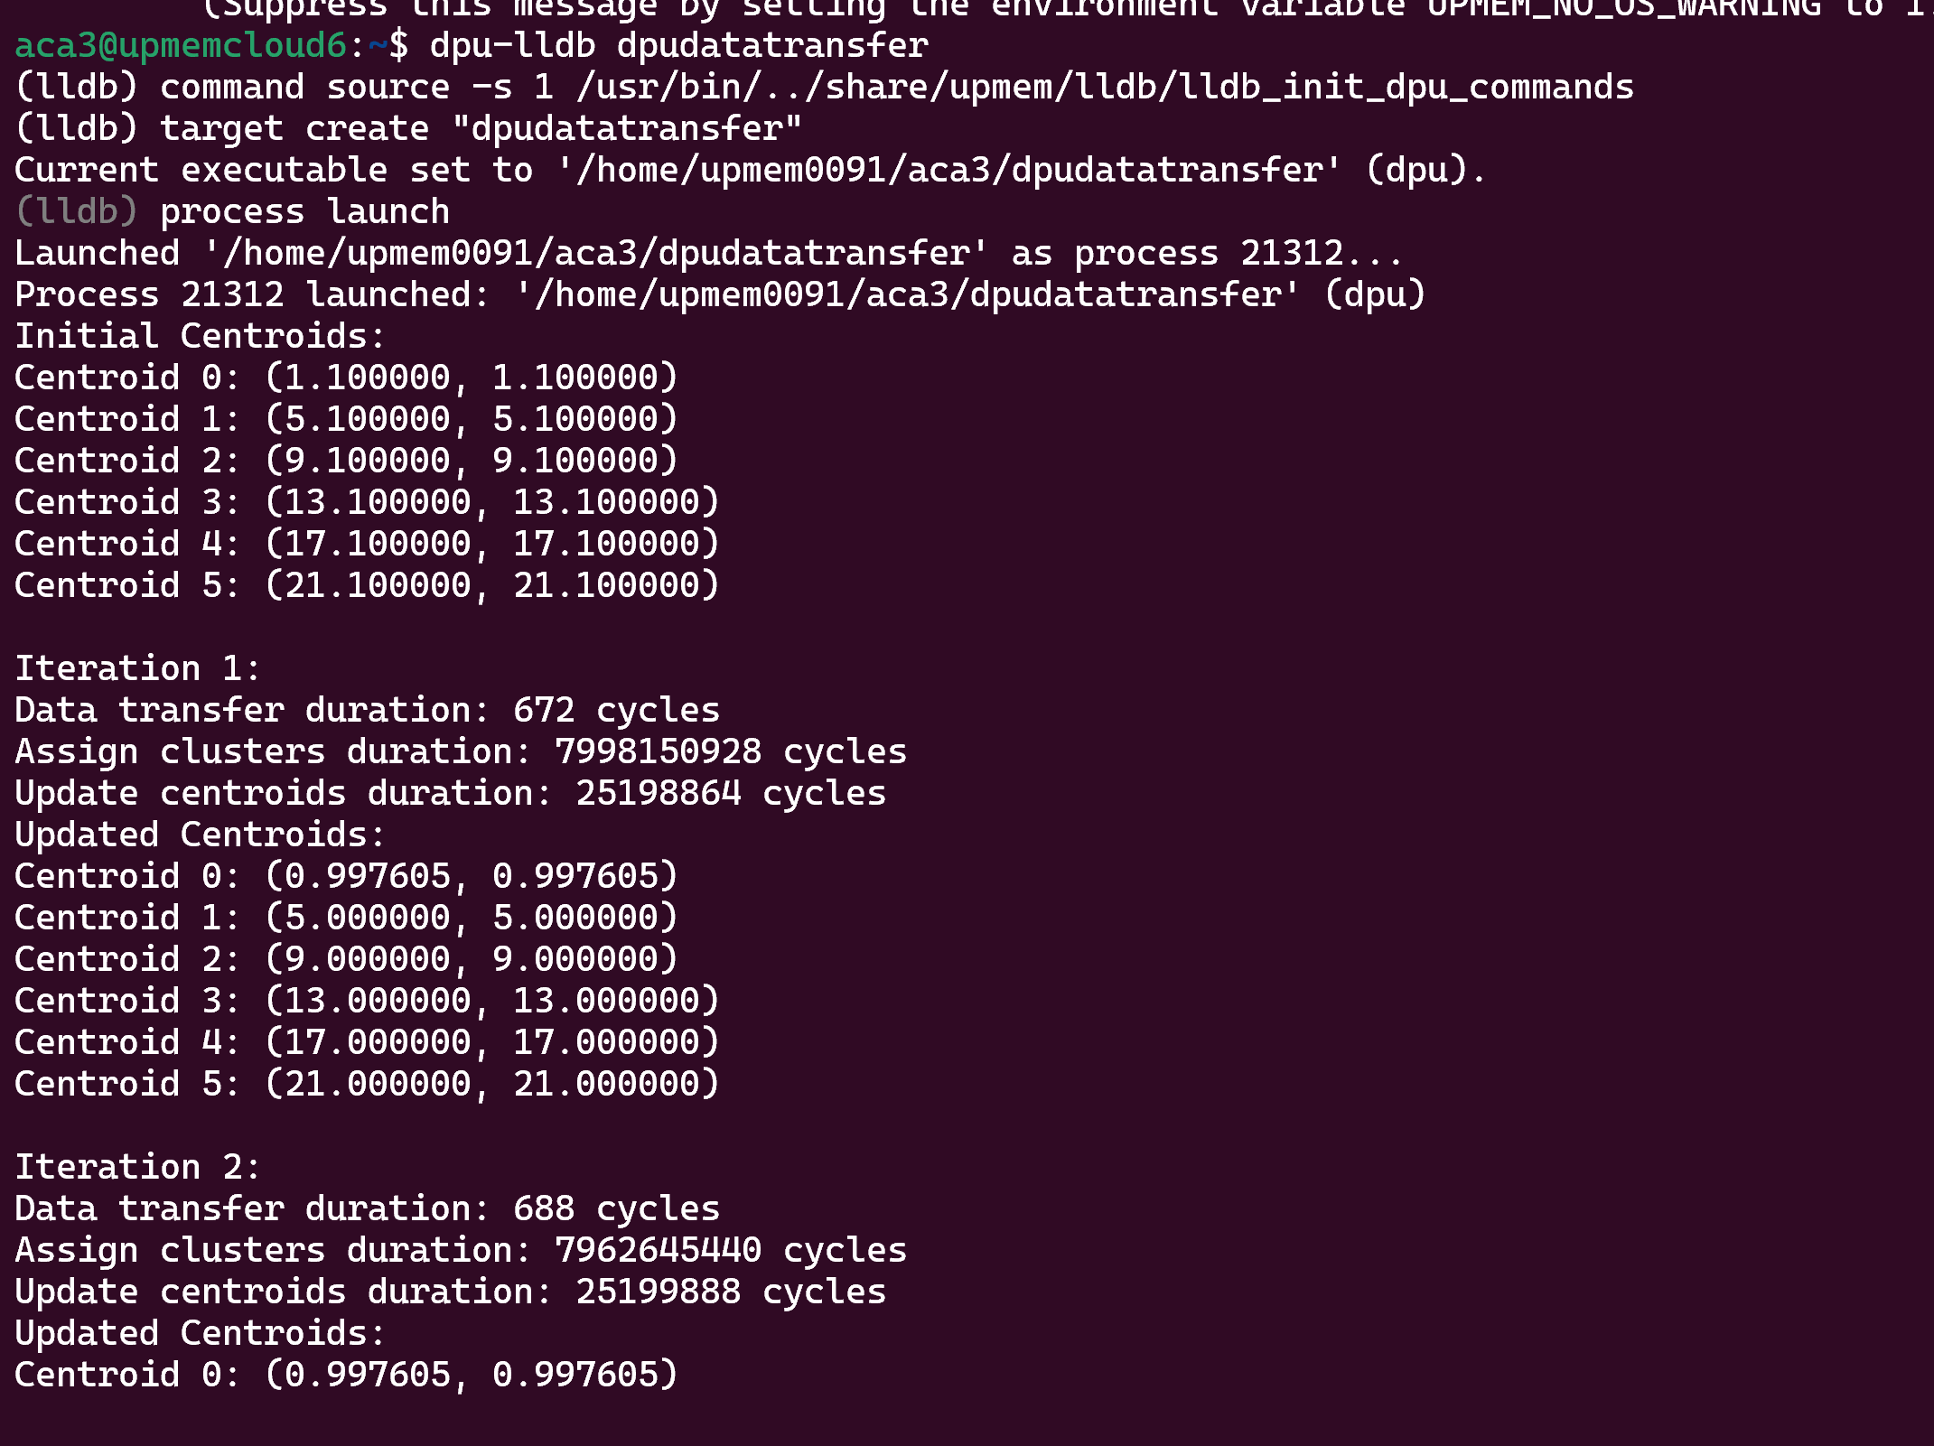

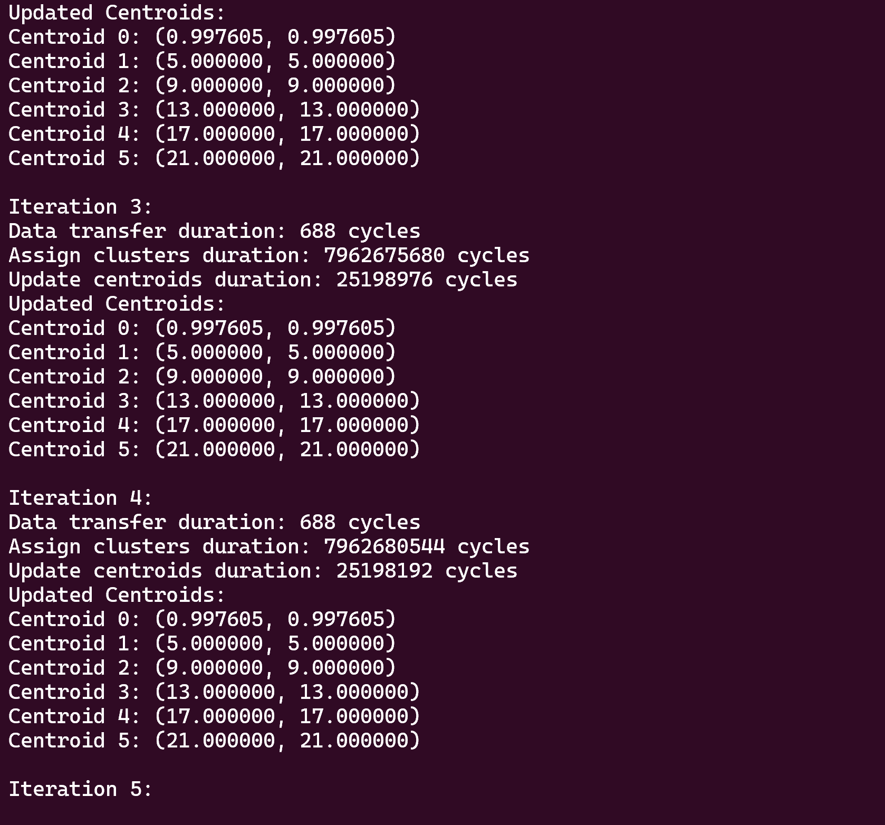

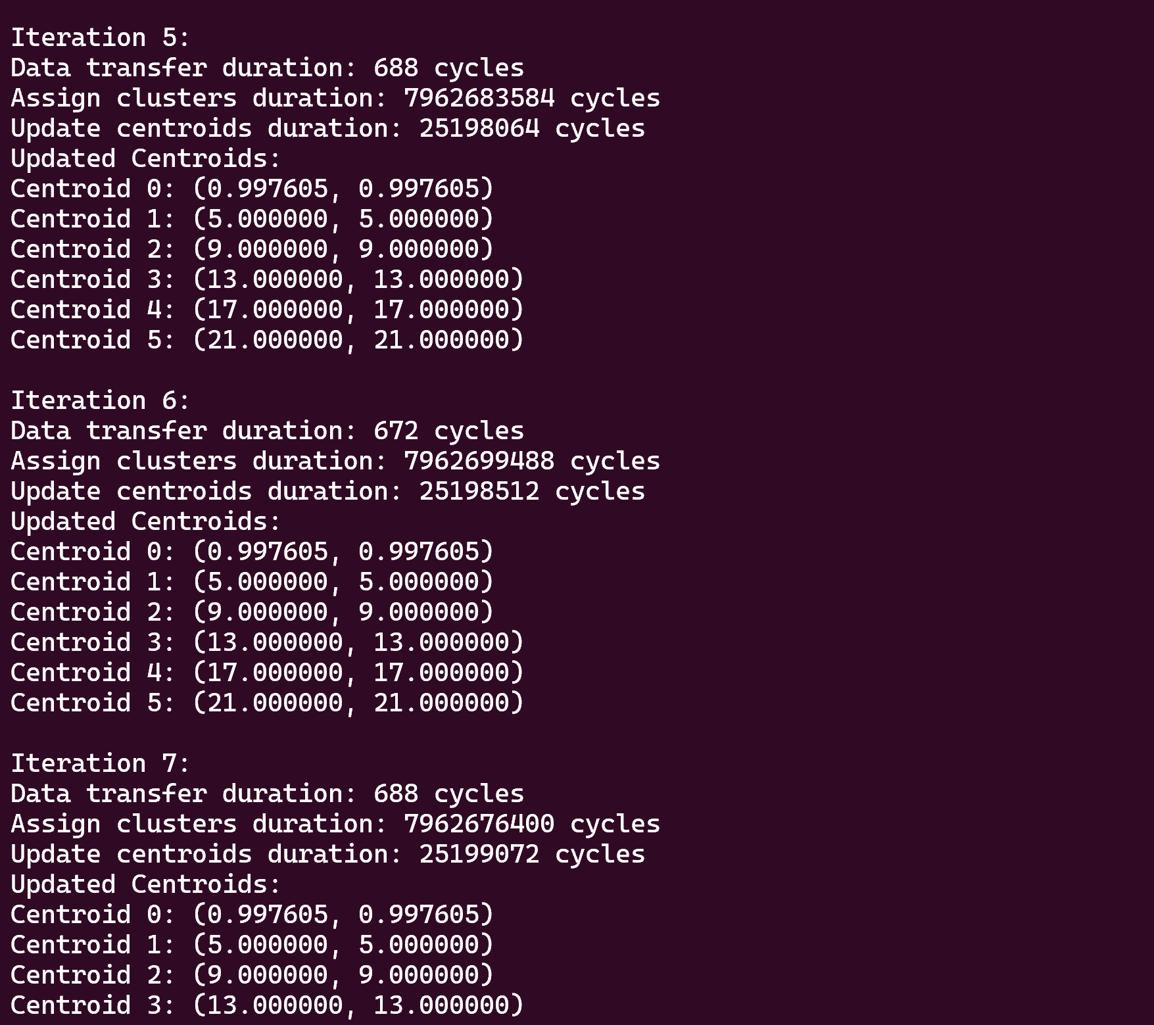

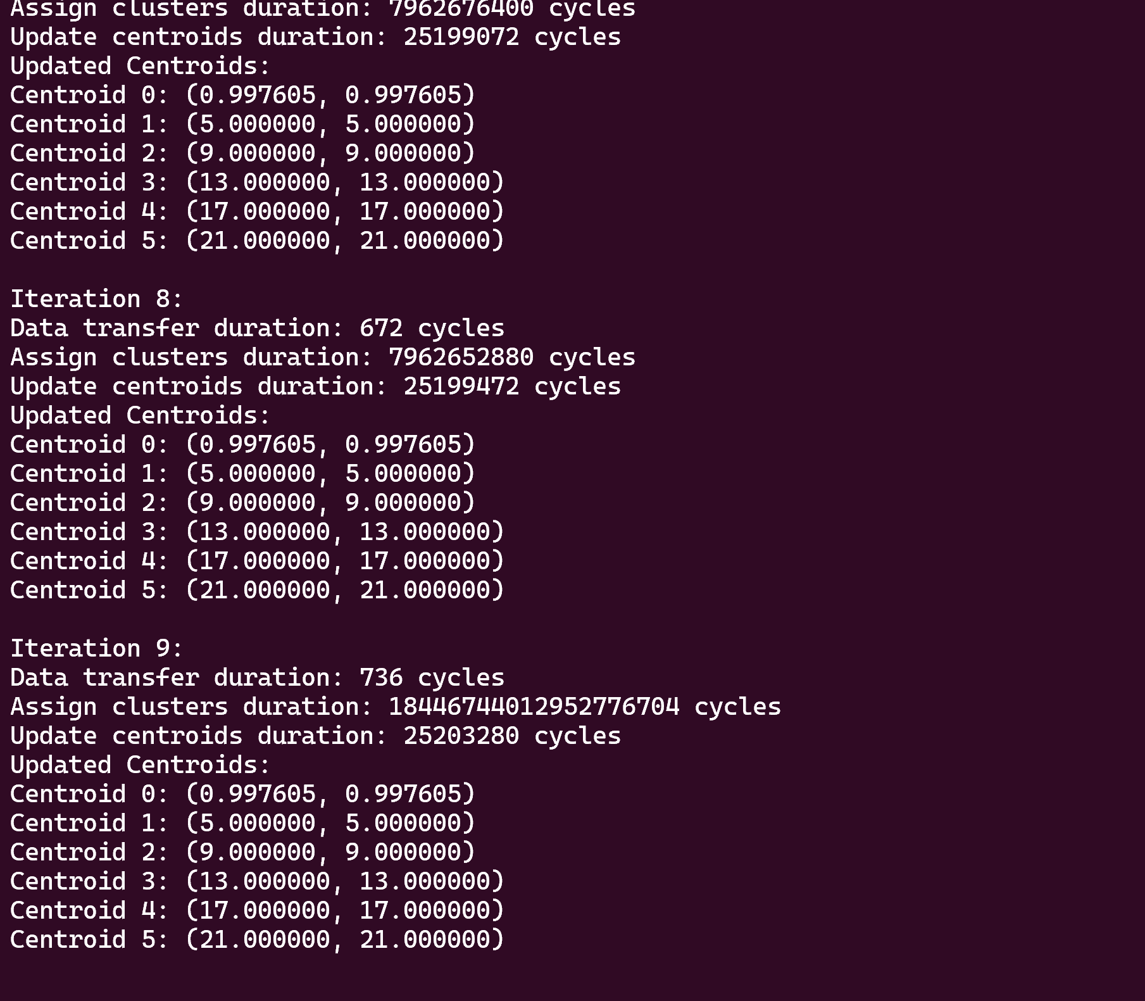

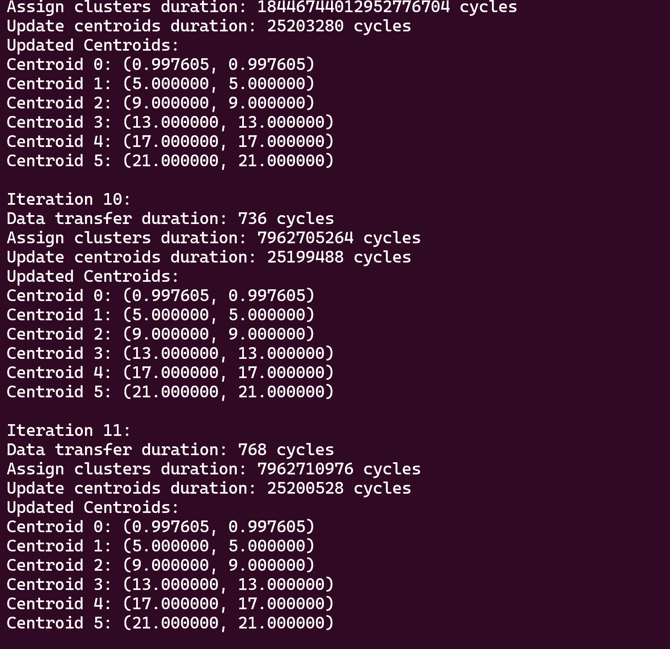

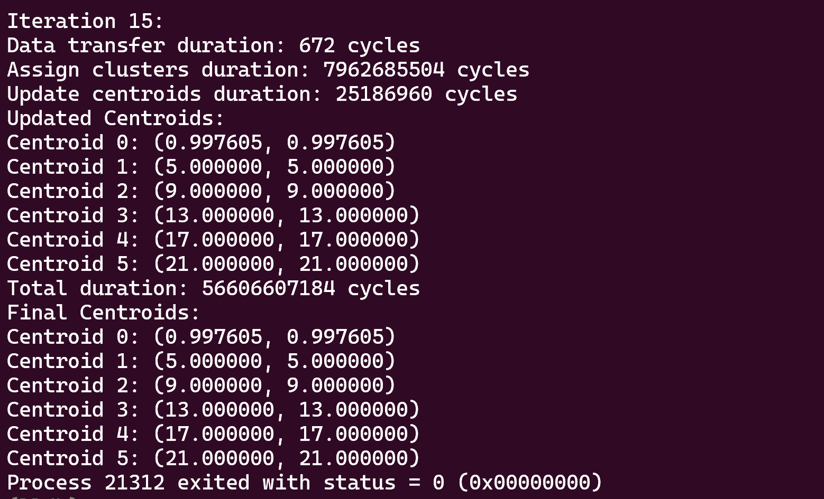

**Noow second parameter:**

**Started at : 5:07 pm stopped at** **5:18 pm**

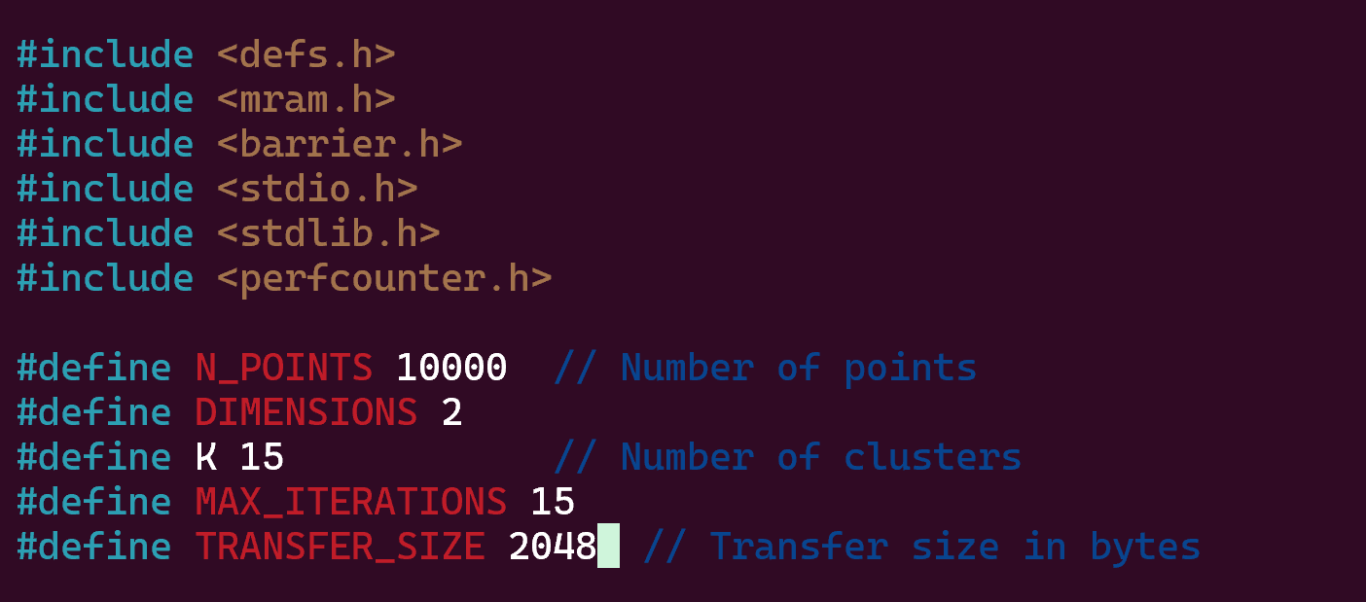

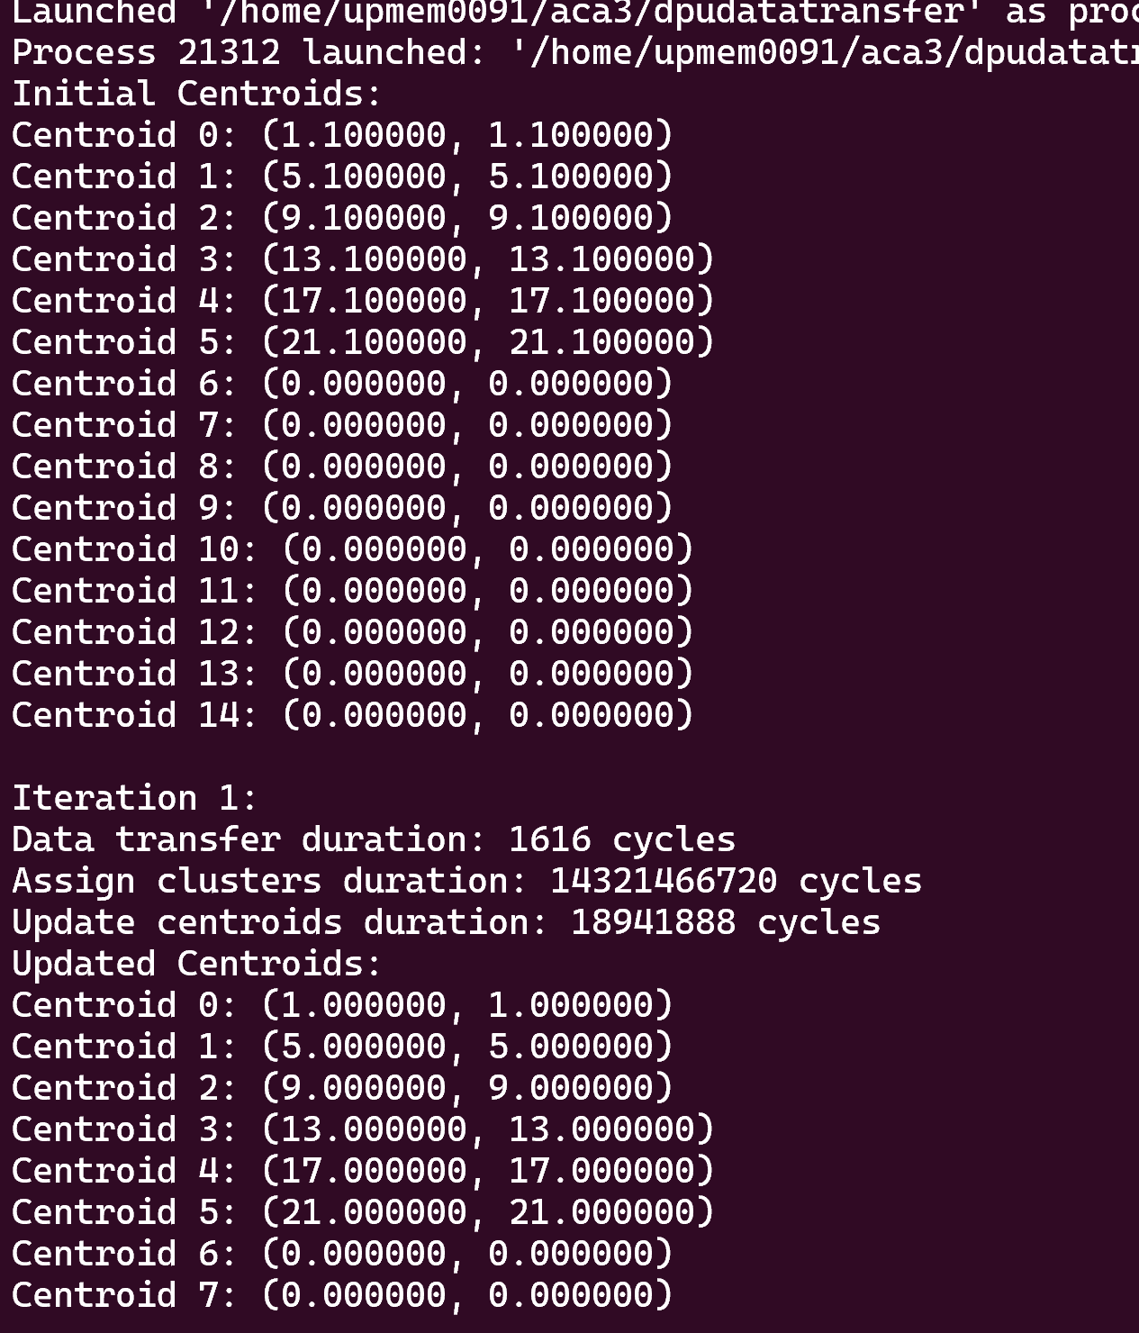

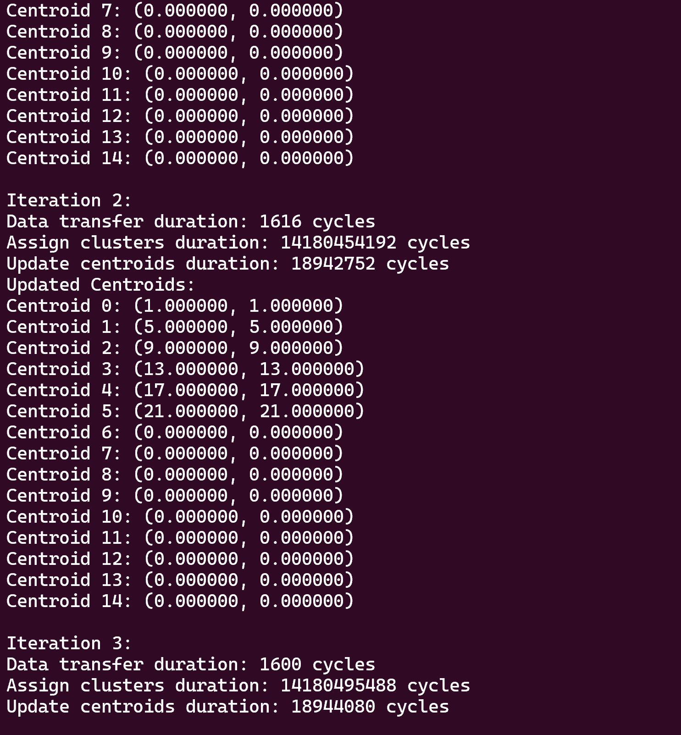

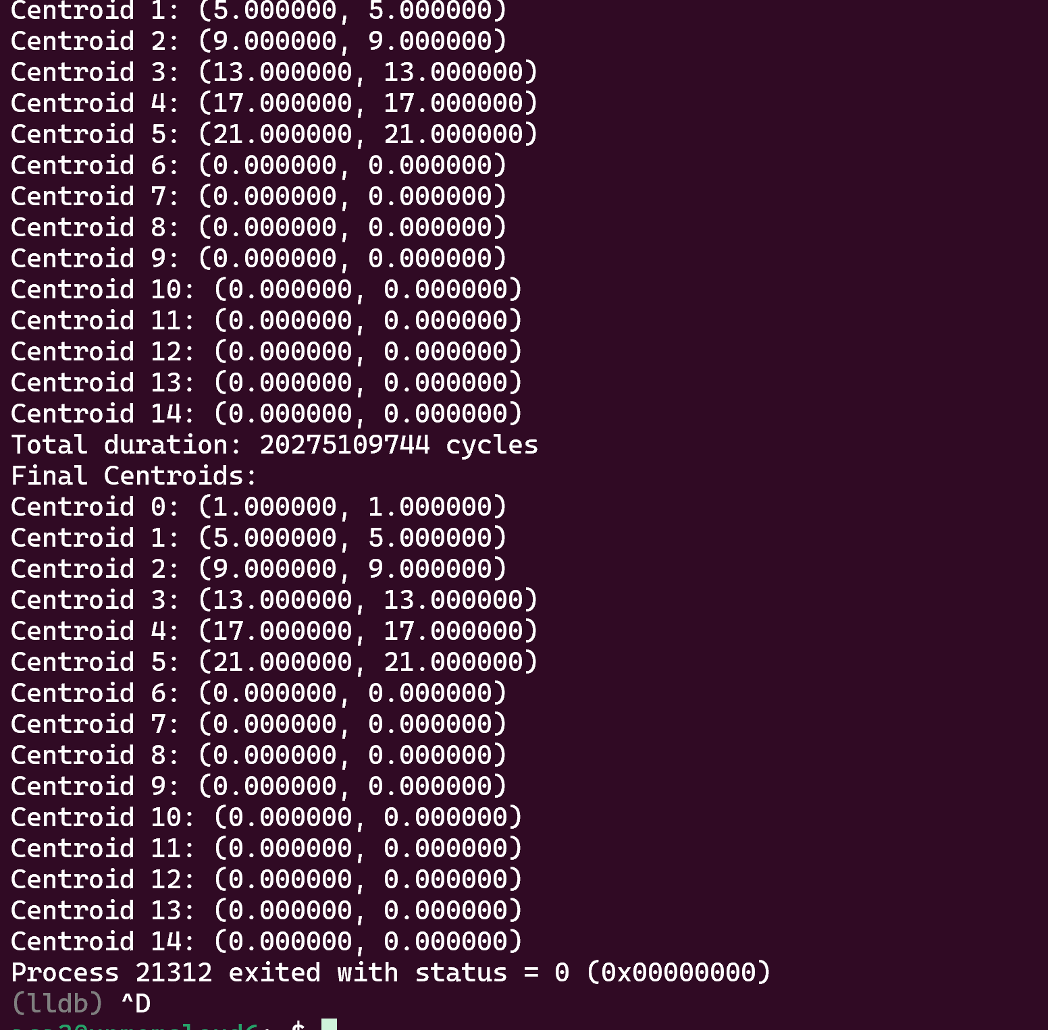

**Third parameter:**

**Now with this point:**

**Started at 5:22 pm and stopped at 5:30**

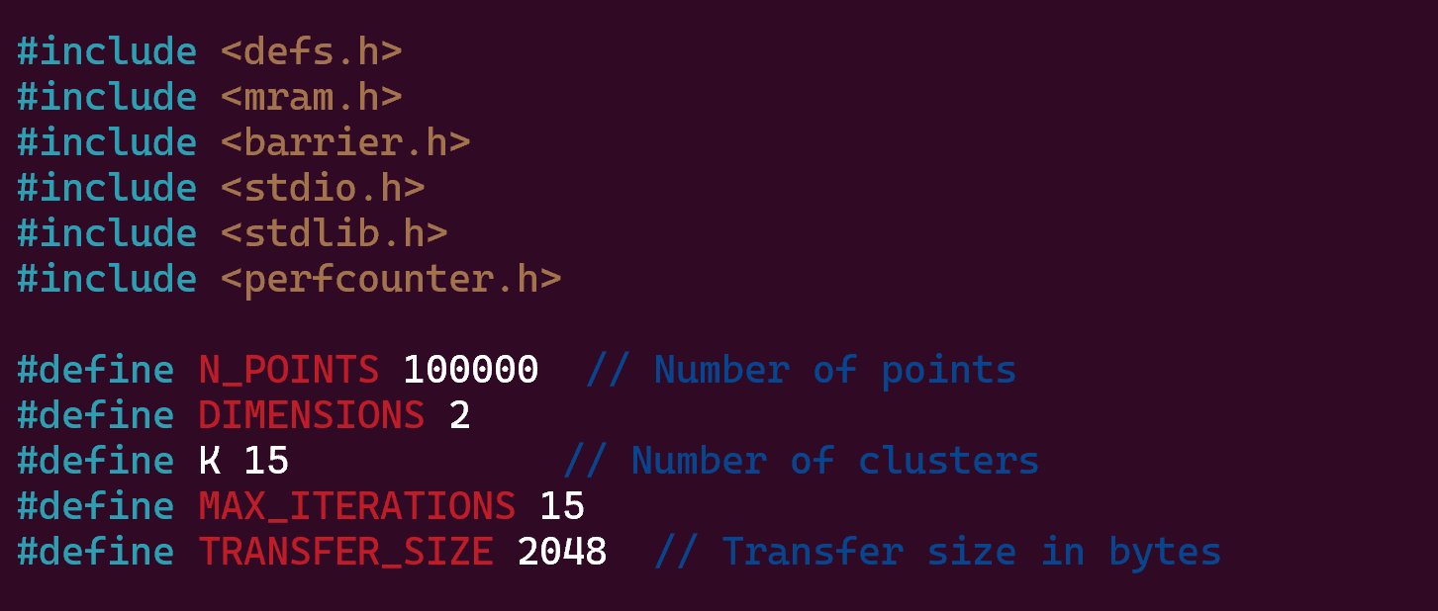

**It was taking first longer time for first iteration itself so I stopped.**

**Fourth Parameter:**

**Now with this point:**

**Started at 5:31 pm and stopped at 5:30**

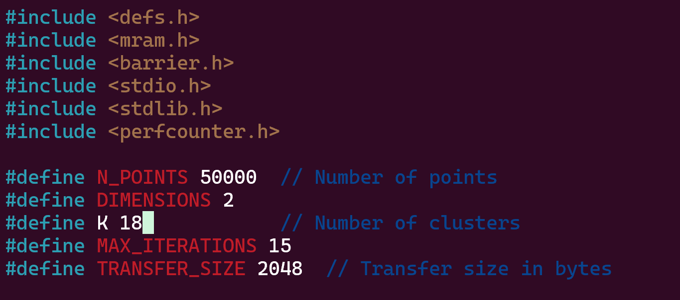

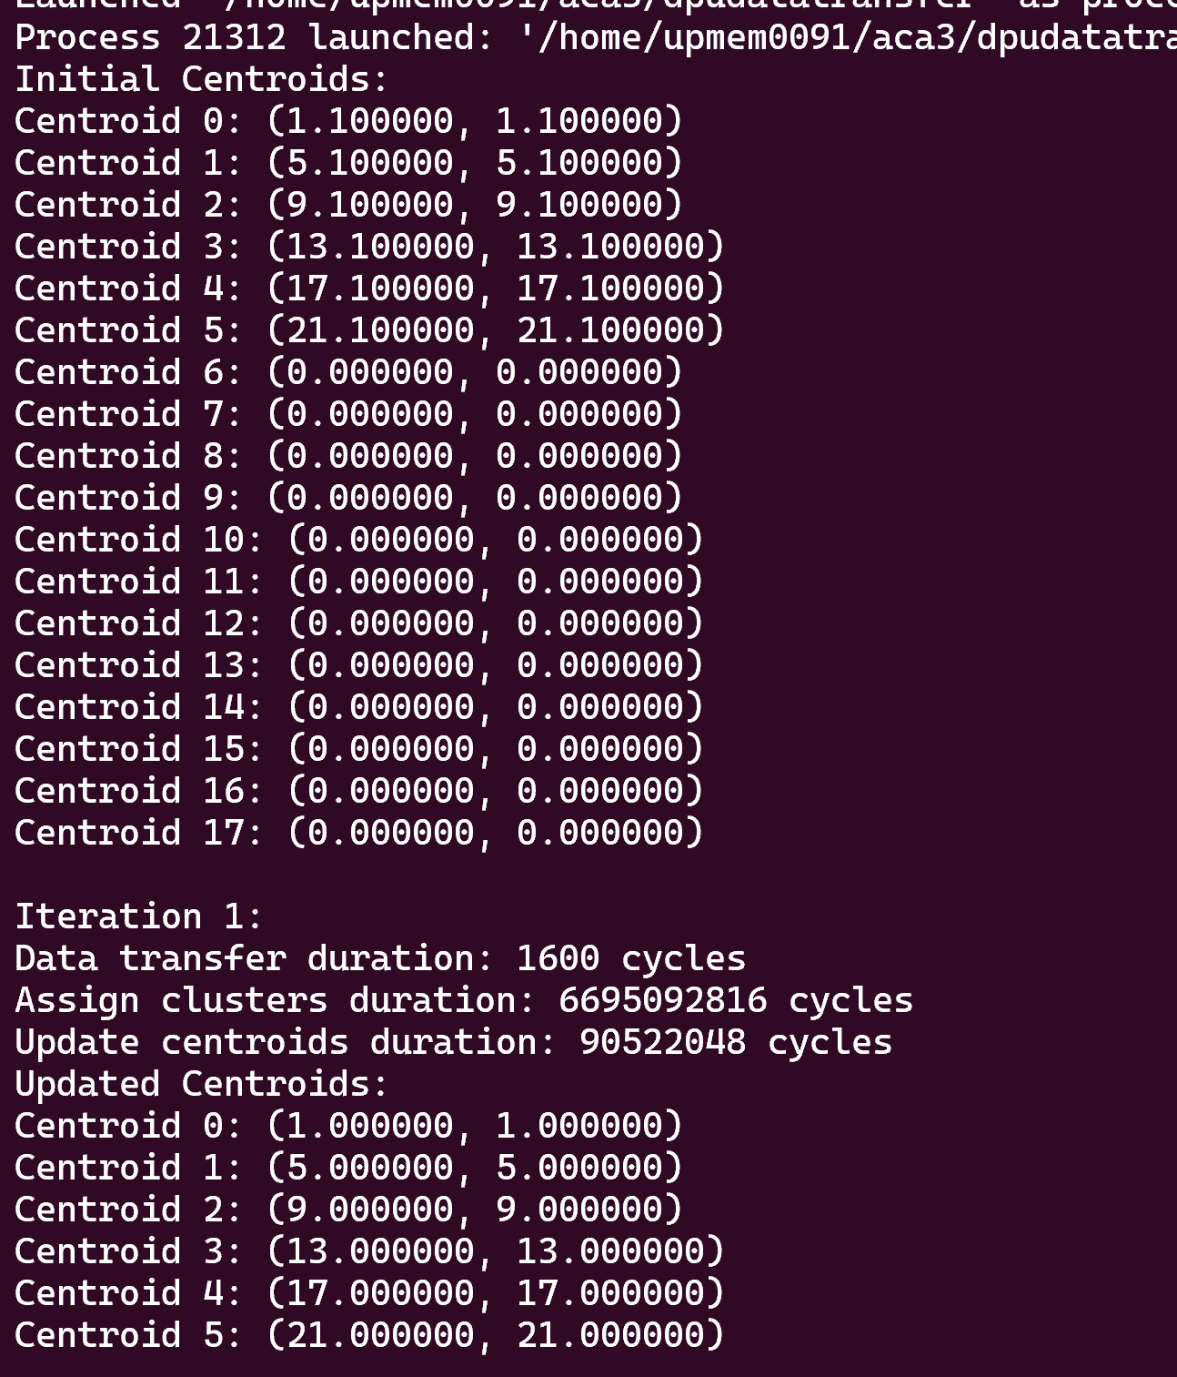

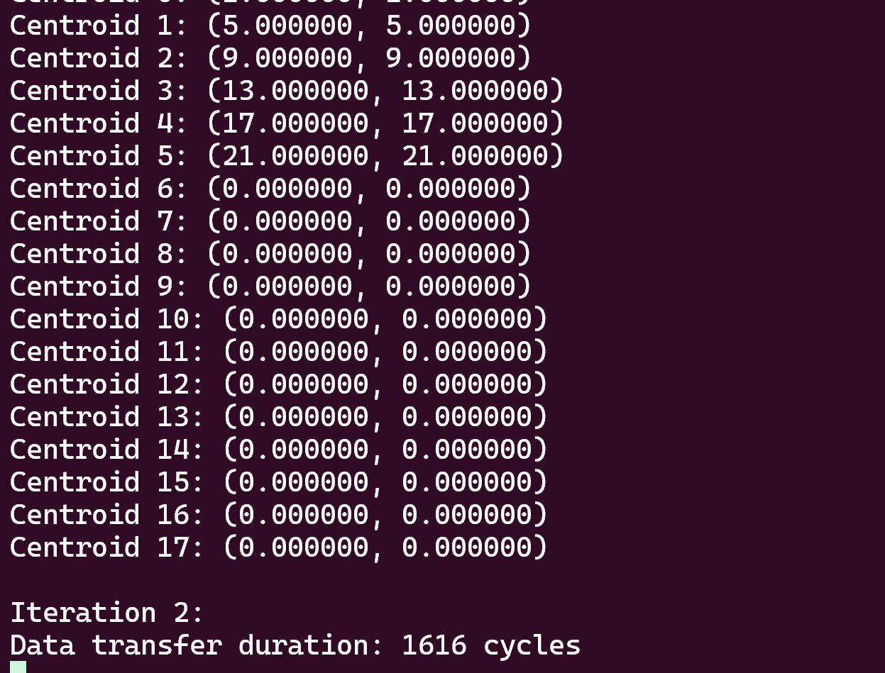

**For iteration it was taking 5 minutes so for whole iteration I think it will take 60 minutes so I had to stopped.**

**Fifth Parameter:**

**Now I am checking with these points: started at 5:38 pm and stopped at: 6:04 pm**

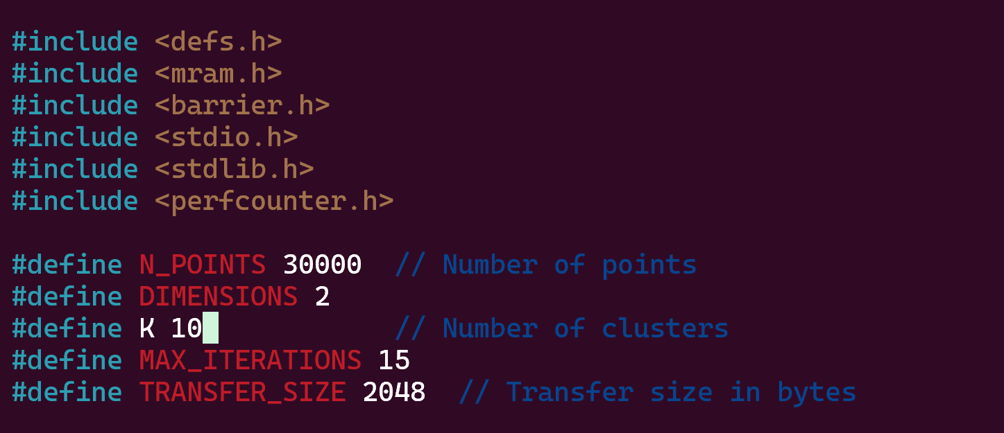

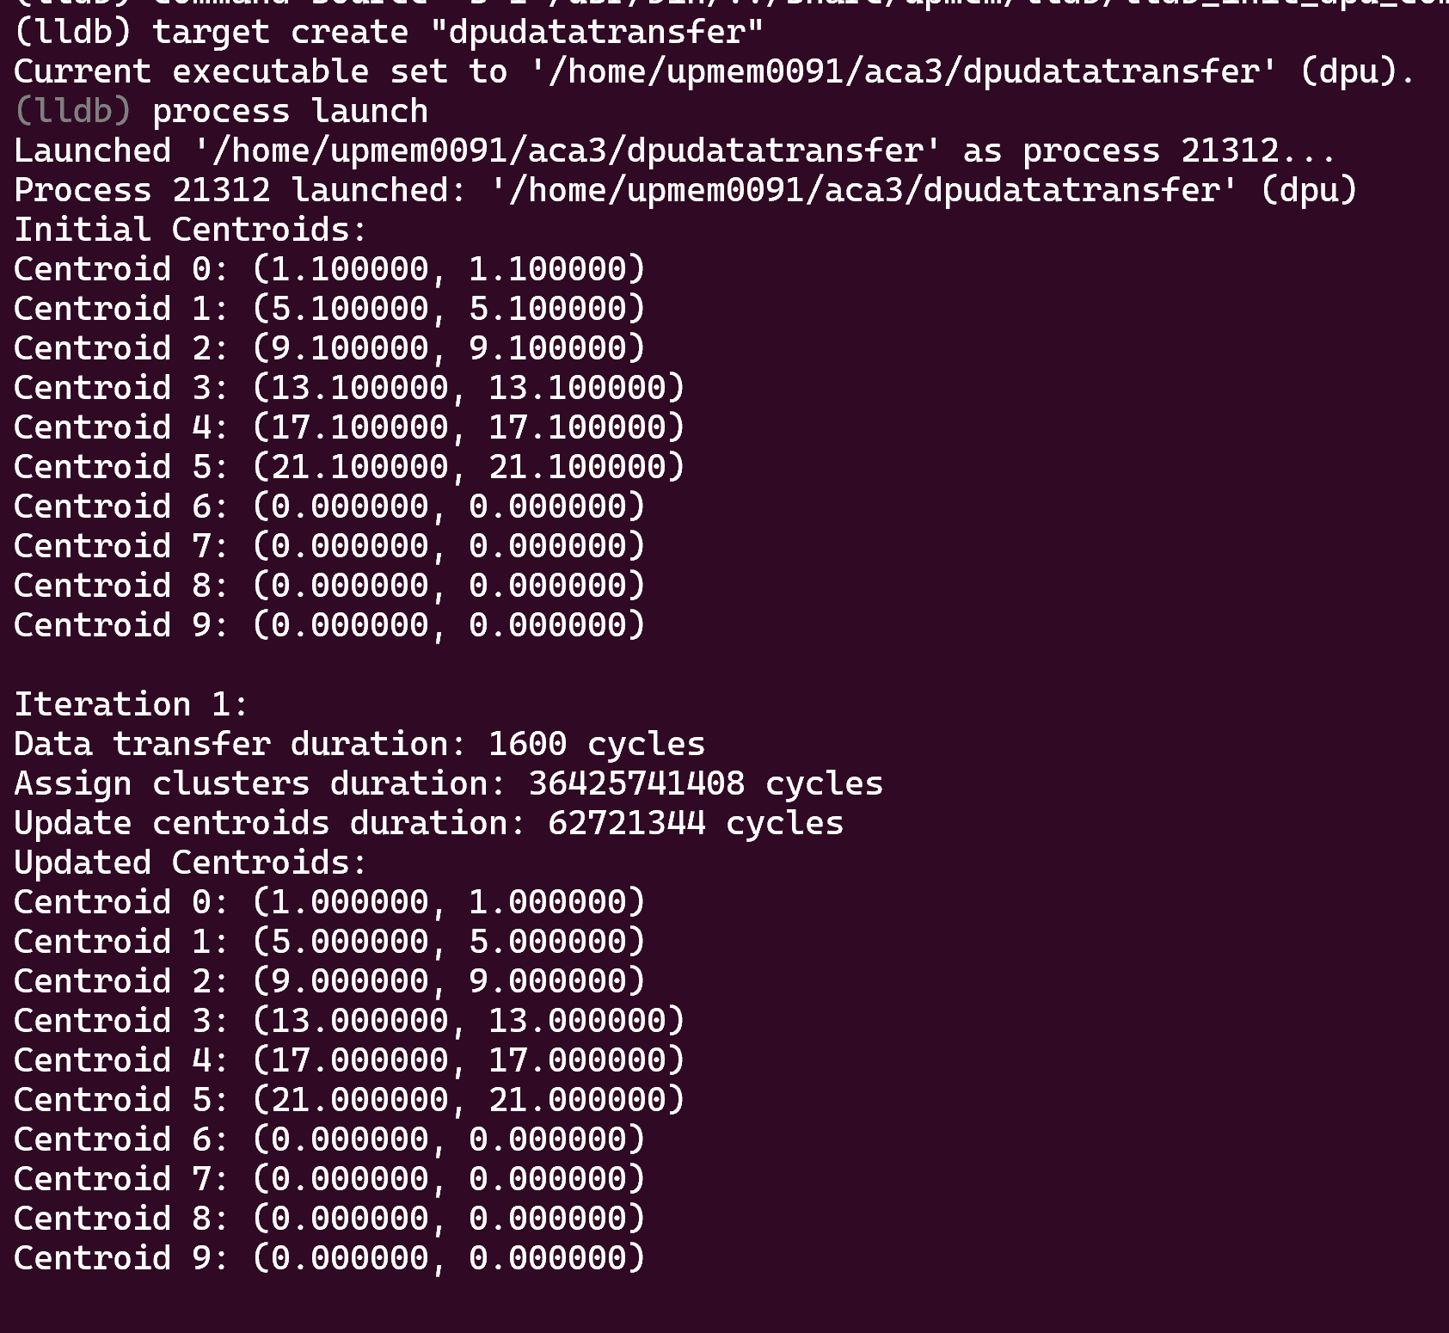

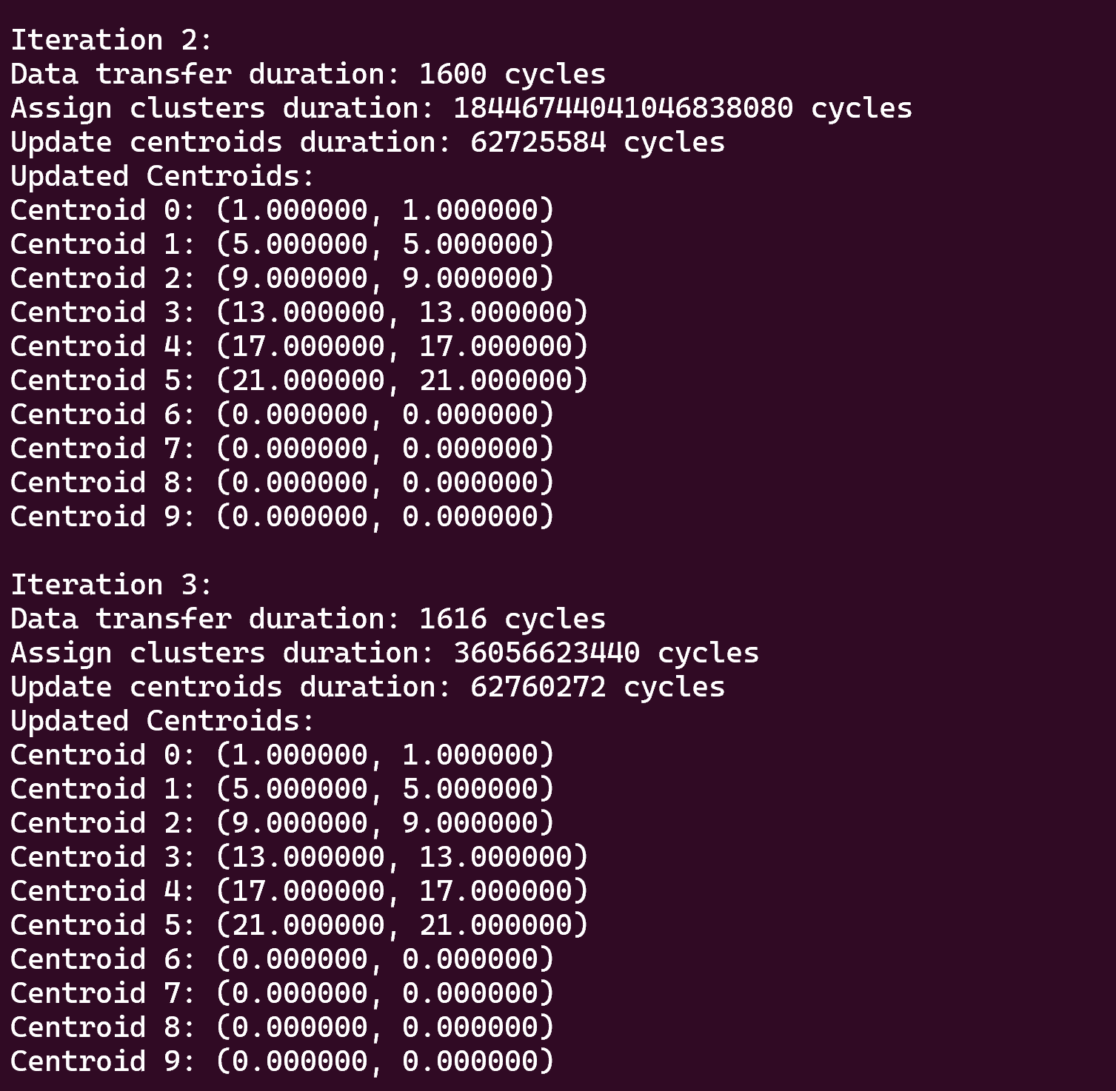

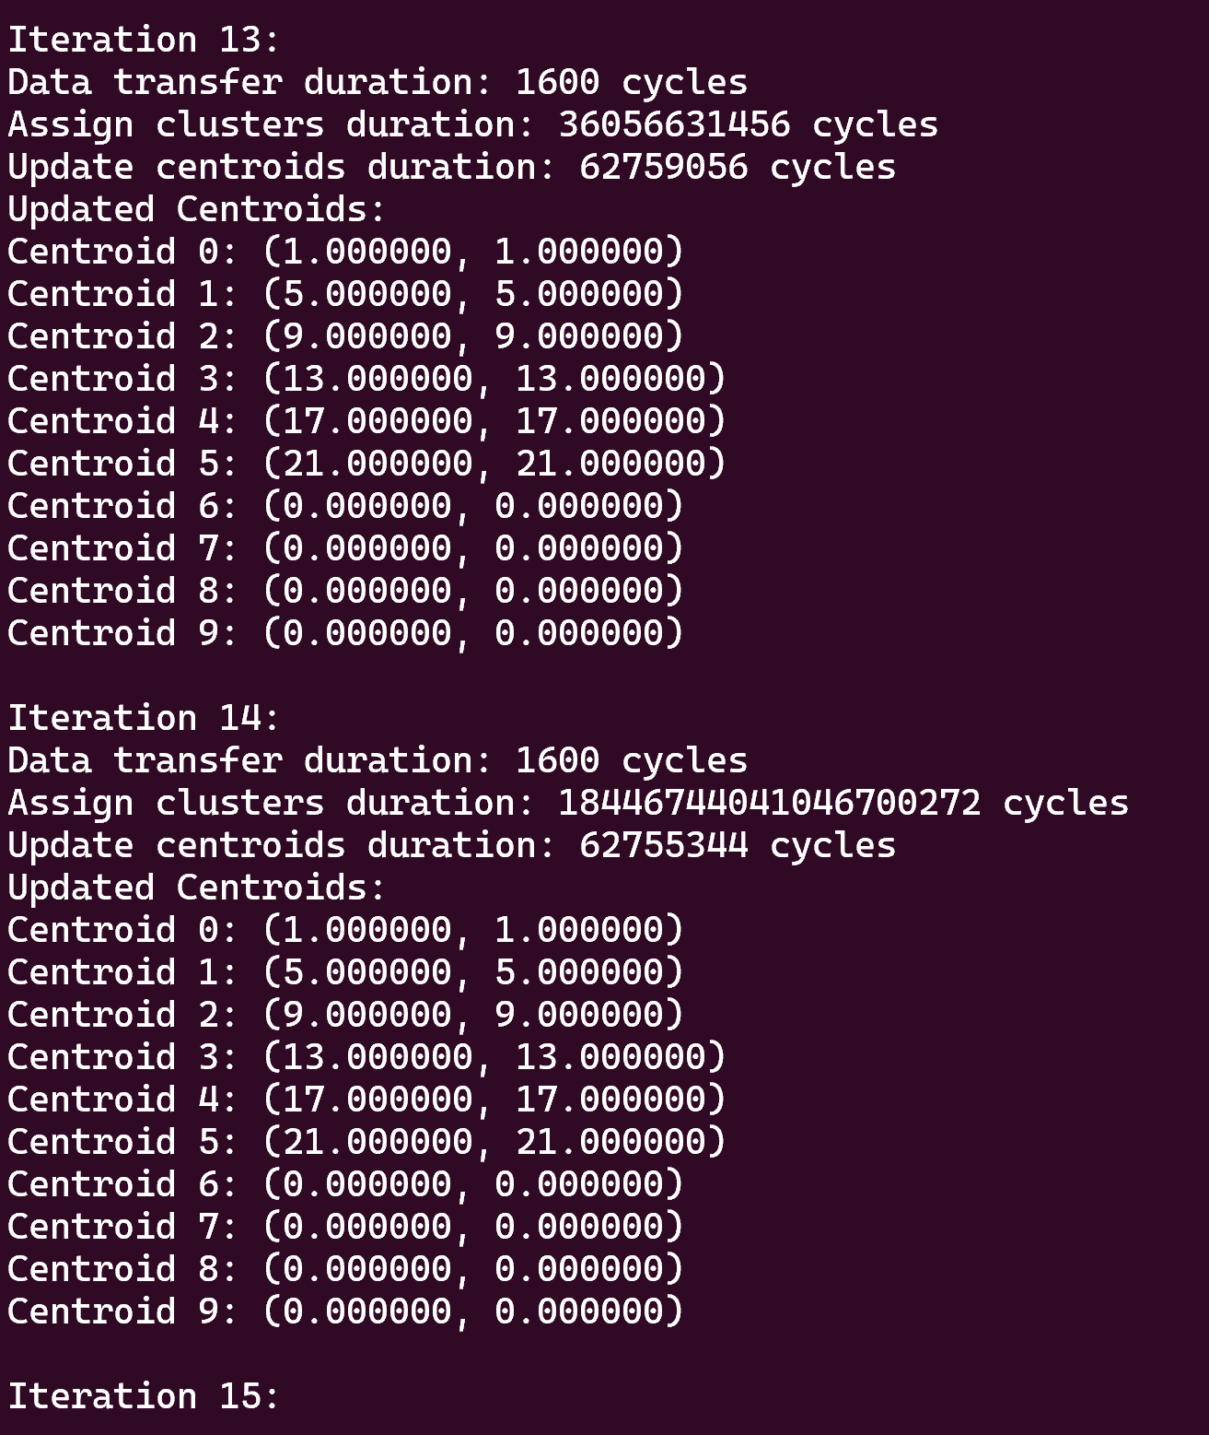

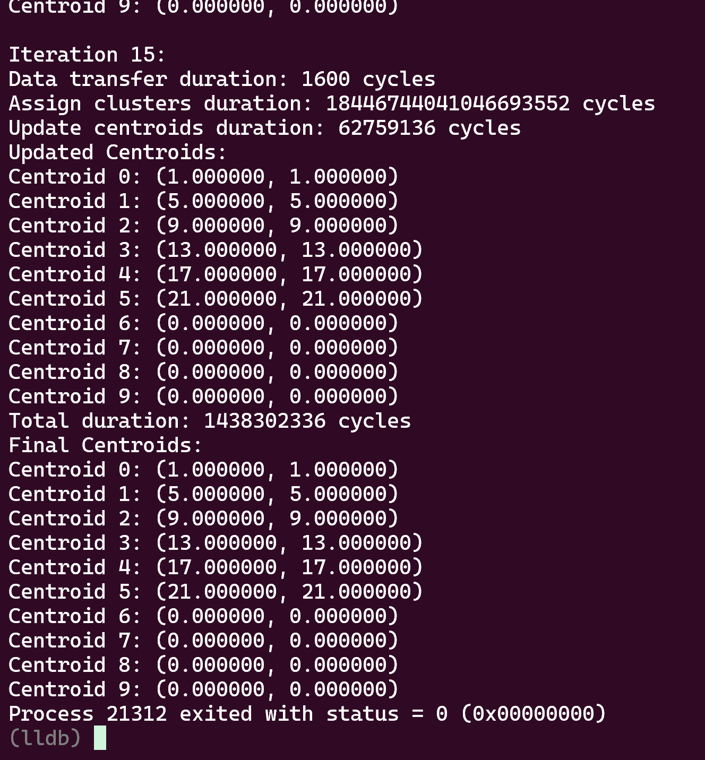

**Sixth Parameter:**

**Now I am checking with these points: started at 7:52 pm and stopped at: 8:50 pm**

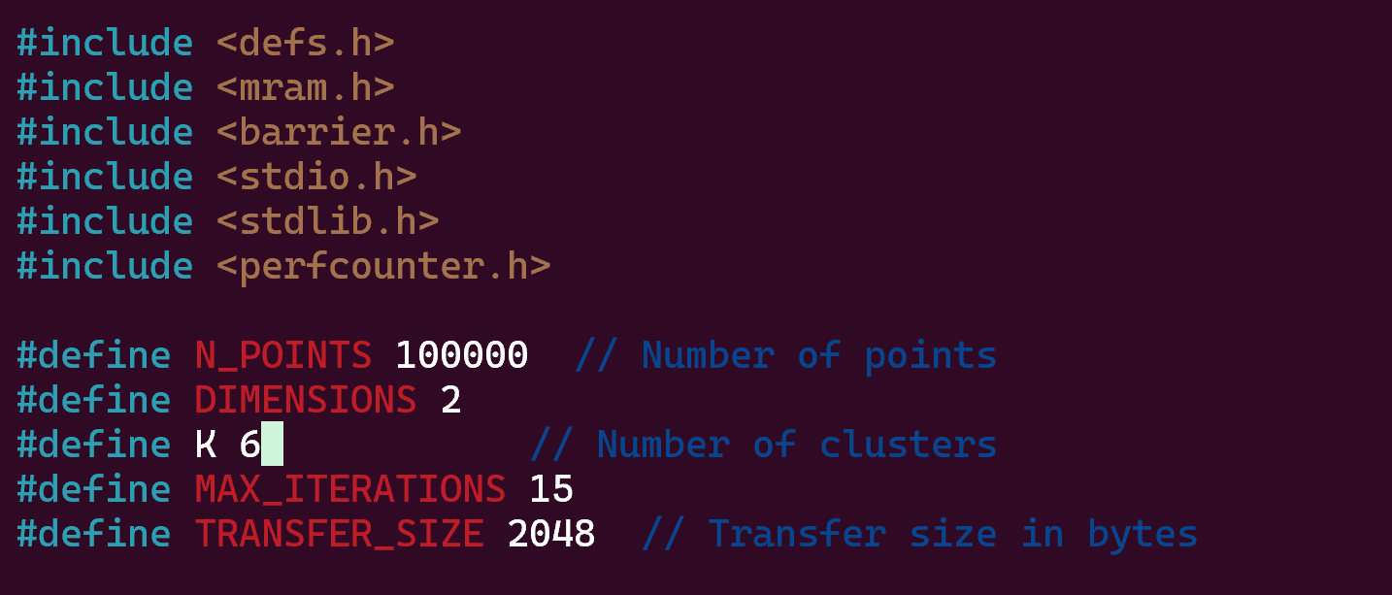

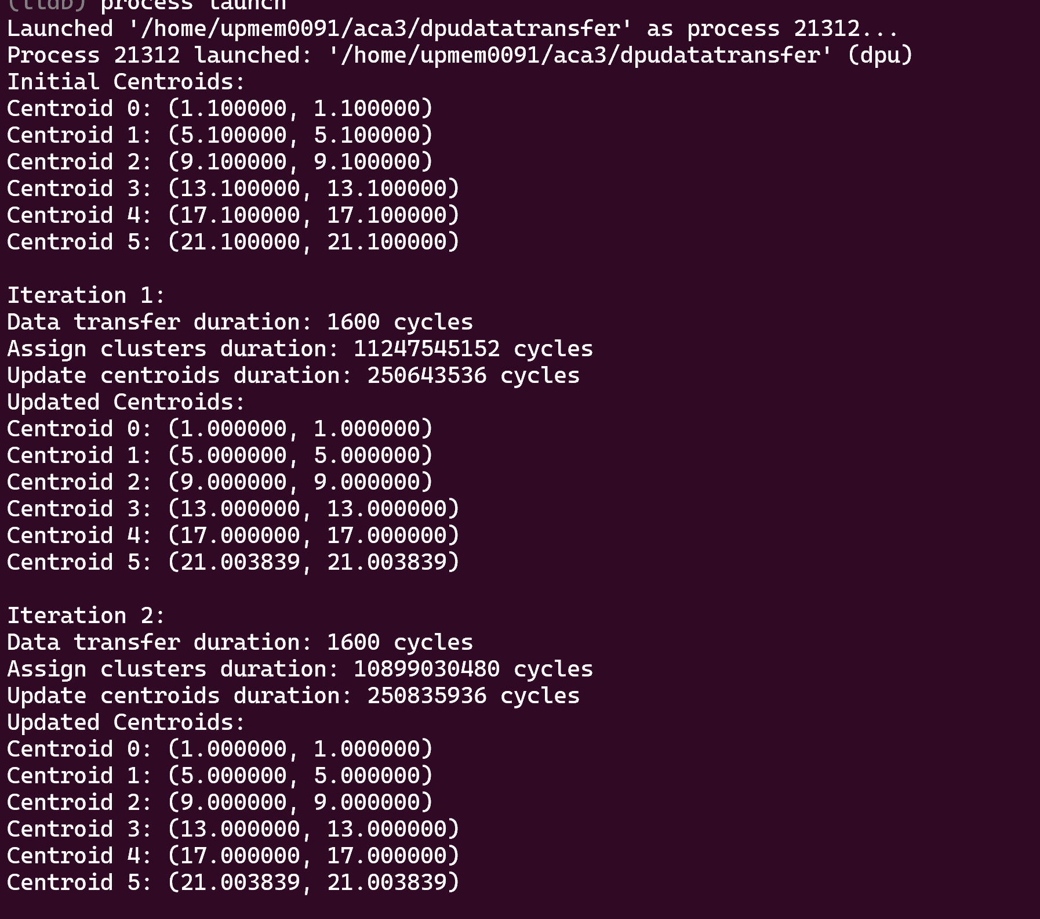

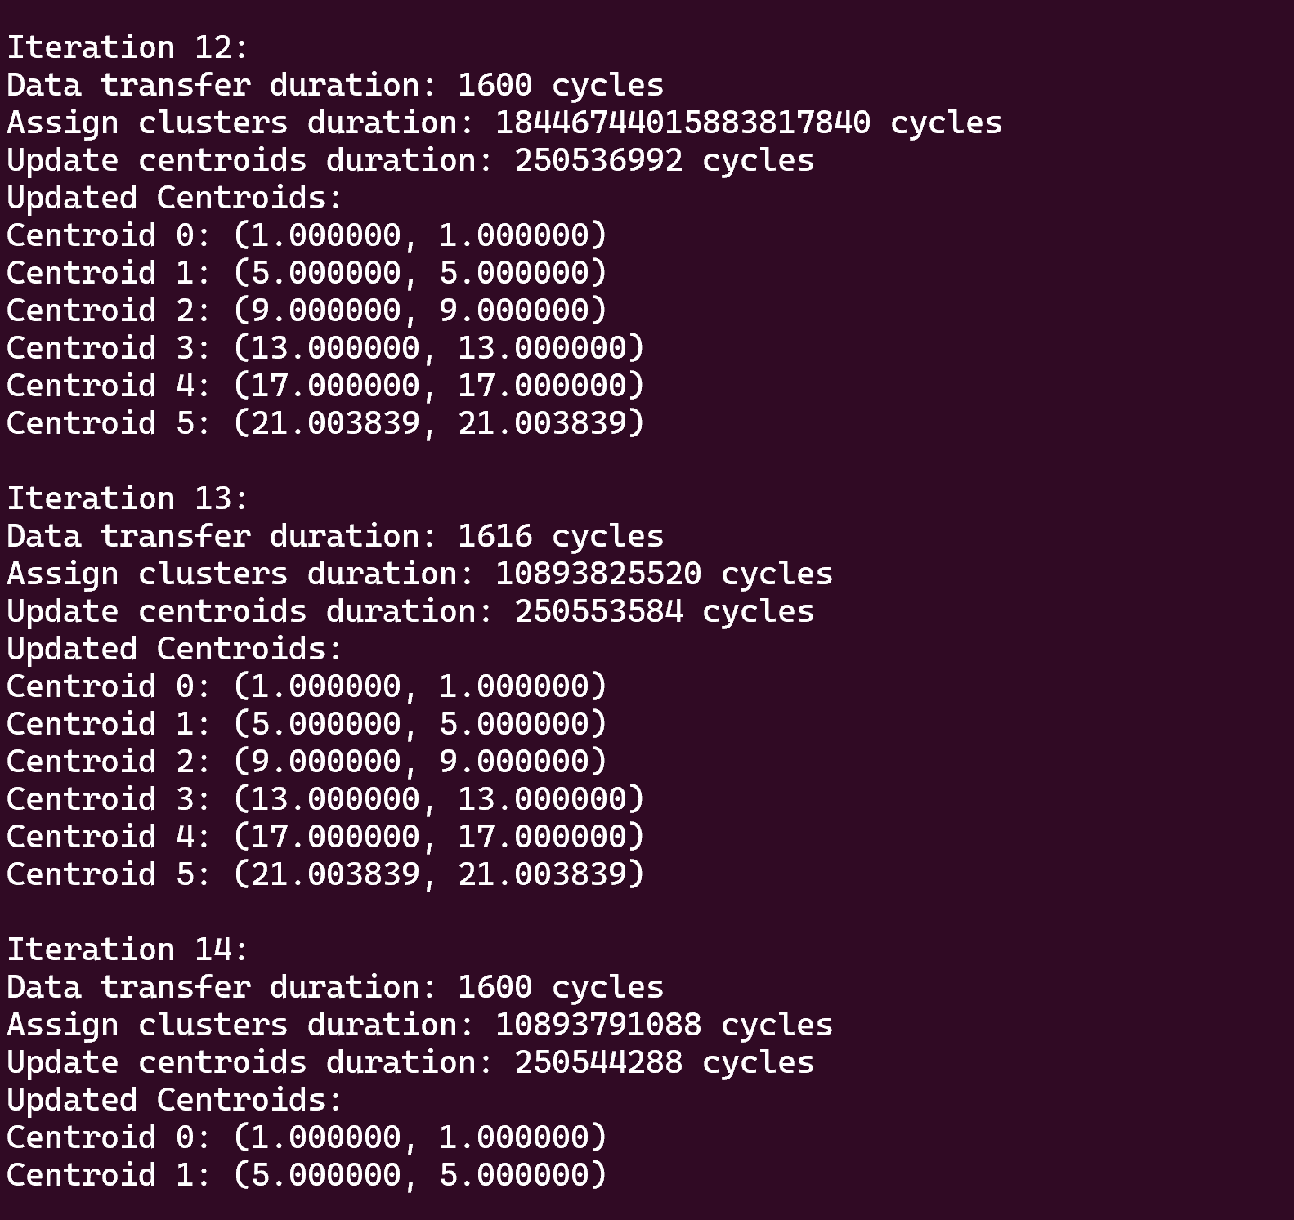

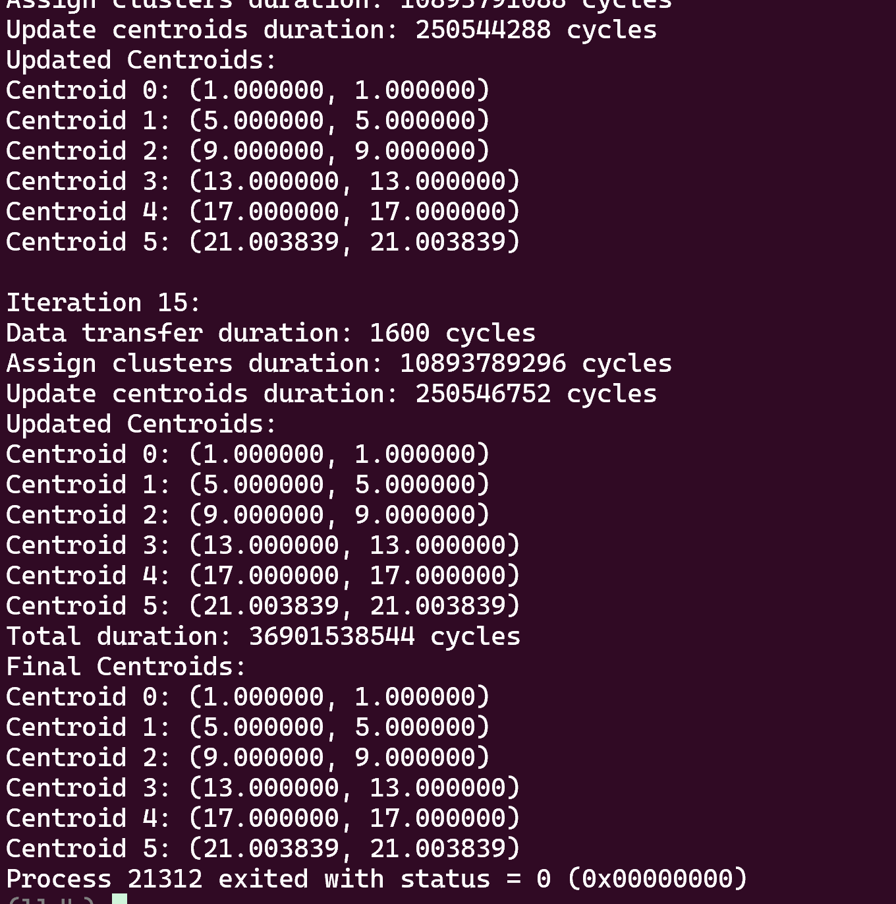

**Seventh Parameter:**

**Now I am checking with these points: started at 10:17 pm and server stopped(because we had access till 12:00 am) at 12:11 am(14th Iteration)**

